EXHIBITION GUIDE

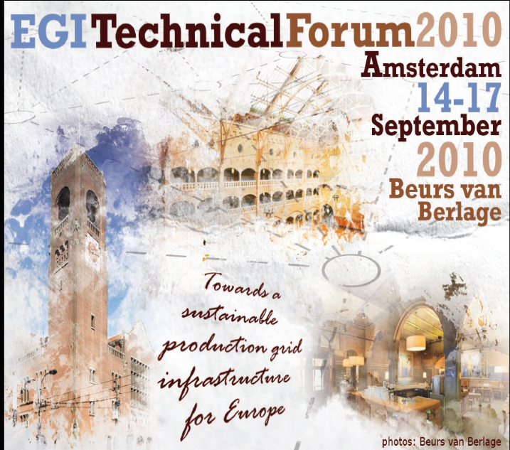

EGI Technical Forum
14-17th September, 2010
Amsterdam - the Netherlands

Deadline for all bookings is 13th August 2010

EXHIBITION INFORMATION

1. Exhibition Area

The exhibition of the EGI Technical Forum will be held on the ground floor Main Hall of the Beurs van Berlage. The main meeting rooms will be located adjacent to the lobby of the Main Hall and on the floor that overlooks the Main Hall. All coffee breaks and luncheons will be served in the Main Hall.

2. Installation

All exhibitors can set up from: Monday, September 13th as of 12.00 hours

General set-up information:

- All packing material which needs to be stored should be cleared from the exhibition area by 19.00 hrs.
- There is no storage space available onsite the Beurs van Berlage.
- Any packaging materials left in the Main Hall will have to be cleared and destroyed after this time.
- The exhibition area will be inspected by the fire department inspection on Monday, September 13 at 20.00 hours.

3. Dismantling

No tear down will be authorized before 14.00 hours on Thursday 16th September, please take this in consideration when making your travel arrangements.

3. Exhibition opening hours

Tuesday, September 14, 2010 09.30 – 22.00 Exhibition Open - Closing
Wednesday, September 15, 2010 09:30 – 17.45 Exhibition Open - Closing
Thursday, September 16, 2010 09.30 – 14.00 Exhibition Open - Closing

Final timings will be announced in due course prior the event. We kindly ask you to follow the exhibition opening times and to make sure that your exhibition booth is staffed during all time.

4. Exhibition set up

EGITF 2010 provides a basic constructed exhibition space (provided via the exhibition supplier Gielissen) which includes a standard basic shell scheme, a small table and two chairs. Carpet is not included EGI Technical Forum exhibition package which will be built directly on top of the wooden floor.

Fire Safety: Flammable Materials / Gases
Exhibitors are advised that the Beurs van Berlage has stringent regulations governing materials used on-site during an Exhibition. The use of flammable materials must be in accordance with the manufacturer's instructions and with due regard for the safety of others. The use of compressed gasses will only be allowed with prior permission from Security. Storage of these materials should always be outside the building, special arrangements for this will need to be made.

5. Shipments and delivery/storage of goods

You are free to choose a freight forwarding company but you can also use the appointed freight forwarder Valverde. They will take care of custom clearance, storage and delivery of your equipment to your booth. All shipments will be delivered to the venue and distributed to the exhibition space on Monday September before 08.00 hours.

Empty cases and boxes need to be stored with Valverde for the duration of the show and will be delivered back to your stands on Friday after the closing of the exhibition.

We advise you not to send any material directly to the venue! The Beurs van Berlage and EGI Technical Forum reject any liability for material which has not arrived or cannot be found due to incorrect addresses. Pick-up of the material must be arranged by Friday, September 17 2010 (immediately after the Forum has ended) and ideally on Thursday afternoon once the Exhibition area has closed. The venue cannot keep any boxes in storage after the tear-down of the exhibition.

The Beurs van Berlage and EGI Technical Forum will not be responsible for any item or material that has not been removed once the event is finished.

Details of loading & unloading access / parking trucks
The Beurs van Berlage is located in the heart of Amsterdam, at the Damrak. The Damrak is the connection between the Dam and Central Station. The Damrak has one-way traffic; you can only approach the Beurs van Berlage from a southern direction.

Loading Information
Loading & unloading take place via special entrances on the Beursstraat, Oude Brugsteeg and Beursplein (at night only). Follow the signs to the Bijenkorf multi-storey car park, and at the exit to this car park take the parallel road and then turn left into the Beursstraat. Please be aware that trucks exceeding 7 tonnes are prohibited from entering the Beursstraat. You can request an exemption from the City of Amsterdam. Each exhibitor is responsible to transport the material to its' designated location. No lifts or machinery of any kind is allowed on the property and the weight of materials may not exceed 250 kg per square meter.

07.00 a.m. - 11.00 p.m.: Via Beursstraat opposite no. 33
11.00 p.m - 07.00 a.m.: Via Beursplein 1-3

6. Registrations

All exhibitors must register for the event using the registration website http://www.egi.eu/EGITF2010

Exhibitors are obliged to wear their badges at all times.

7. Services

Catering
The Beurs van Berlage can supply exhibitors with food and drinks they require on their booth. The EGI Technical Forum is organizing coffee breaks. luncheons and drinks for all participants. You are very welcome to arrange activities to attract participants to visit your booth as long as it does not coincide with our official program, sponsorship activities and social events. Please contact us for approval!

Cleaning and refuse
The venue will be responsible for cleaning the main area and public areas within the exhibition on a daily basis. Basic cleaning of the booths is not included with the rental of a shell scheme (excluding the emptying of dustbins).

Electrical Fittings and Mains:
According to the regulations, the organization will only provide a standard multi-way socket (220 Volt.) if additional electricity is needed, please contact the organization

Photographs
None of the exhibits may be photographed or filmed without the permission of the exhibitor. The EGI Technical Forum is entitled to photograph, draw or film the exhibition and to use these reproductions in press releases and other publications, in accordance with the venue.

Security
The organizers will provide general security guard services in the exhibition area during closing hours. The exhibitor shall be responsible for the security of his booth during the exhibition opening hours. Exhibitors are recommended to pay close attention to their booth, also during construction and dismantling periods. Valuable objects which may easily be removed, such as portable computers, should be secured during the day and being removed during the night and not be left unattended. EGI Technical Forum and the Beurs van Berlage accept no responsibility for goods stolen from exhibitors.

If you have valuable equipment on your stand, we strongly advise ordering additional security for your own stand.

Storage
Packing cases must be removed from the exhibits. You should therefore make prior arrangements for the safekeeping of such items with Valverde.

Transport regulations / handling
Valverde will be able to give you the necessary recommendations and support for transporting your material.

General Information

1. Hospitality activities
The EGI Technical Forum has adopted a policy, which limits industry sponsored presentations and other formal gatherings. Without the specific approval of EGITF, exhibitors may not organize such events or presentations between September 14, 15 and 16 2010.

Please contact us if you plan any activities during the above dates.

2. Hotel Bookings
A number of hotels in various price categories have been booked for the EGI Technical Forum. Capacities will be released prior the event. For deadlines and the available hotels, please visit our website. http://www.egi.eu/EGITF2010

All rates quoted on the hotel reservation page on the EGI Technical Forum website are per room per night. Your reservation will be handled by RAI Hotel service. Exhibitors are advised to reserve rooms in advance.

3. Insurance
It shall be the responsibility of each exhibitor to maintain such insurance against injury to person or theft, fire damage or loss of property in such amounts as the exhibitor shall deem adequate. Insurance protection will NOT be given to the exhibitor neither by EGITF nor the congress venue or any other party involved in the organization of the EGI Technical Forum.

Exhibitors should therefore arrange their own insurance, in their capacity as exhibitor of the EGI TF 2010, against any claims which may arise from loss of or damage to exhibition materials, as well as against any claims which may ensue from transportation to and from the congress venue and against any claims which may be made by third parties with respect to injury or damage sustained in any way whatsoever inside or outside the venue.

5. Final Clause
In cases not or not clearly covered by the regulations in the Guide for Exhibitors, EGITF’s and the Beurs van Berlage decision shall be final.

EGITF reserves the right to make changes in the layout of the exhibition, to deviate from the space confirmation and to allocate a place in a different location, to alter the size of the booth, to re-allocate or close entrances and exits on the exhibition grounds and/or in the Congress venue and to carry out structural alternations providing it has substantial interest in such measures, based on special circumstances. It is not possible to change booth location onsite!

CONTACT ADDRESSES

Exhibition Space
Overall Organization
Contact person: P.W. Burgmans
Jan van Goyenkade 11
1075 HP Amsterdam
Netherlands
Phone: + 31 20 679.34.11
Fax: + 31 20 673.73.06
E-mail: burgmans@eurocongress.com
Website: http://www.egi.eu/EGITF2010

Beurs van Berlage
Meeting venue
Contact person: Mrs. Daphne Drupsteen
Damrak 243 - Beursplein 1-3
1012 ZJ Amsterdam
E-mail: DDrupsteen@beursvanberlage.nl
Website: www.beursvanberlage.nl

Stand catering
+31 – 20 – 531. 33. 55
RAI Hotel and Travel Services
Hotel booking
Contact Person: Mrs Susan Boogert
Phone: +31 20 549 1546
Email: hotelservice@rai.nl
Website: www.maisonvandenboer.com

Valverde BV
Shipment / Custom Clearance / Storage
Contact Person: Mr Gert Veenstra
Triport 1, 6th Floor
Evert van de Beekstraat 46
1118 CL Schiphol
The Netherlands
Phone: +31 20 653 8555
Fax: +31 20 653 7658
E-mail: gert@valverde.nl
Website: www.valverde.nl

PROVISIONAL FLOOR PLAN MAIN HALL

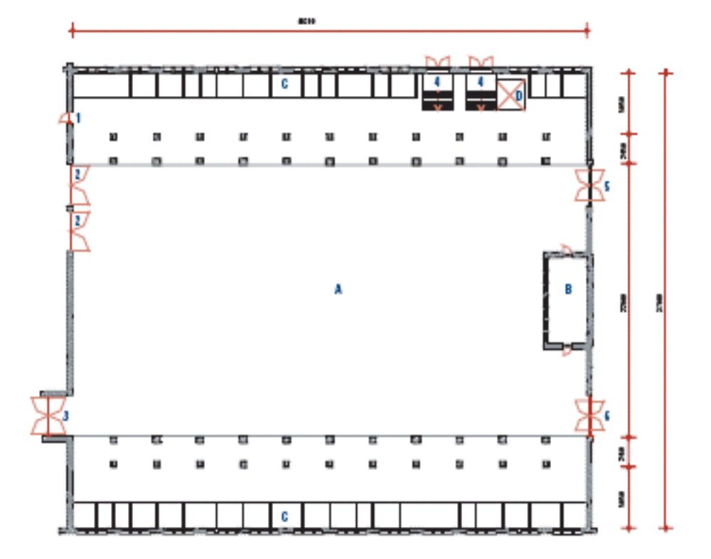

Exhibition Booths

Poster / Lunch / Coffee area

Exhibition Booths

CONTRACT FOR EXHIBITION SPACE DURING EGITF 2010

Company name:

Address:

Zip Code: City:

Country:

Contact person:

Phone: Fax: E-mail:

Web page:

We would like to exhibit during the EGITF2010 conference:

Stand, rental period 14 – 16 September 2010, prices incl. 19% VAT

❑ Commercial organization € 1250,00

❑ Academic and/or Collaboration project € 800,00

Containing: 3 x back panels shell scheme, 2 side panels, standard multi-way socket (220 volt), basic lighting

EXTRA’S, rental period 14 – 16 September 2010, prices incl. 19% VAT
(2 Chairs & 1 Round Table included in the basic stand costs)

❑ Chair …. x € 20 per piece € ………..

❑ Round Table  …. x € 60 per piece € …………

❑ Rectangular Table …. x € 50 per piece € …………

❑ LCD screen …. x € 600 per piece € …………

❑ Beamer + screen …. x € 650 per set € …………

❑ Brochures rack …. x € 100 € …………

❑ Counter …. x € 130 € …………

TOTAL € …………
contract page 1 of 2

Company name (for nameplate):

INVOICE AND PAYMENT
Undersigned declares that the sum of EUR _________________, representing 50% of the total amount being sent within 3 weeks after receipt of the invoice of the first instalment by bank transfer Fortis Bank Rotterdam, Account Number: 64.23.83.596, Swift / BIC Code: FTSBNL2R, IBAN Number NL72FTSB0642383596. Made payable to: Stichting FOM, stating the following: 1. your company name, 2. EGITF ’10 – NIKHEF, 3. your invoice number.

TERMS AND CONDITIONS
The undersigned is fully aware of the terms and conditions of the general regulations set out enclosed and accepts without reservations.

CANCELLATION POLICY
The organizers shall retain:
- 50% of the agreed sponsorship package cost if the cancellation is made until 2 months prior to the Conference

- 100% of the agreed sponsorship package cost if the cancellation is made less than 1 month prior to the Conference.

We undertake to send all marketing materials to the organisers of the EGITF ‘10 conference by the given deadline and to fulfil payment of the exhibition fee when indicated in the present application.

DATE & PLACE: _______________________

AUTHORIZED REPRESENTATIVE: _______________________

SIGNATURE: _______________________
contract page 2 of 2

